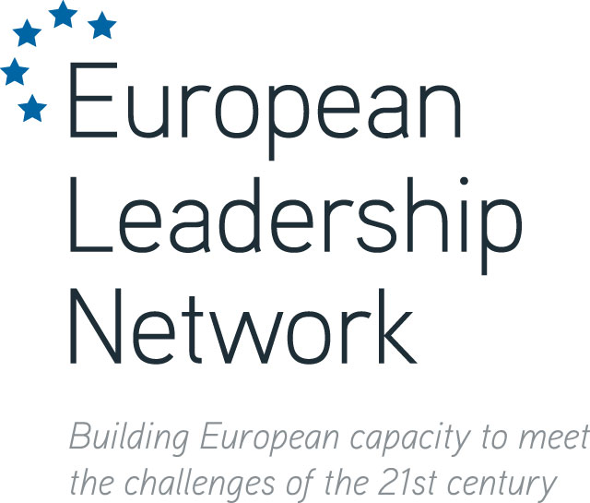

PRESS RELEASE
EMBARGOED UNTIL: 00:01, Tuesday 17 December 2013 (GMT)

In Wake of Ukraine Crisis, European Leadership Group Calls for a New Dialogue on Mutual Security

In the midst of a major crisis in Ukraine, European heads of state meet on 19-20 December to discuss EU defence policy. This is welcome, but the Summit’s focus on European capabilities and procurement will come at the expense of little or no discussion of the evident deep political and security divisions within Europe itself.
In a joint statement, 70 senior European politicians, military figures and diplomats drawn from across the continent and across the political spectrum, argue this is a major missed opportunity.
The group, coordinated through the European Leadership Network (ELN), notes that across the entire Euro-Atlantic region today, dangerously out of date Cold War security policies, weapon systems and military postures remain in place. This:
- increases security risks on the continent;
- reduces the ability of all Europeans to work together to meet common external threats;
- fosters mistrust across the old Cold War divide;
- and costs European tax-payers heavily in extra spending on defence at a time when economic and social pressures are huge.
The group therefore calls for an urgent, politically mandated, dialogue in support of improved mutual security through:
- Enhanced transparency and predictability in Euro-Atlantic military affairs, to decrease fear of a short warning attack anywhere on the continent;
- Measures to increase leadership decision time, especially in relation to the thousands of nuclear weapons in Europe, many of which remain on short notice to fire.
- A single new security construct covering all elements of offence and defence, nuclear and conventional weapons, and cyber-security and militarisation of outer space;
- Steps to reduce the role of nuclear weapons as an essential part of any nation’s overall security posture in Europe, without jeopardising the security of any of the parties;

---
Note to Editors
The full statement, including all signatures, is now available for download in English.
The statement will be made available in German, French, Italian, Spanish, Russian and Turkish on 16 December.
The statement is issued in the names of the signatories and not on behalf of the ELN organisation as a whole.
For further information please visit: www.europeanleadershipnetwork.org

ELN Press Contacts
Dr Ian Kearns, Director, ELN
Tel: +44 (0)7939 604 915 / +44 (0)203 176 2552
Email: iank@europeanleadershipnetwork.org

Shata Shetty, Deputy Director, ELN
Tel: +44 (0)203 176 2554
Email: shatas@europeanleadershipnetwork.org

